FINANCE
333 Broadalbin Street SW, PO Box 490, Albany, Oregon 97321-0144 | PHONE 541-917-7500

PUBLIC NOTICE COOPERATIVE PROCUREMENT

Notice is hereby given that the City of Albany intends to establish a contract with Xiologix LLC, in Tualatin, Oregon, to purchase Fortinet firewall support and warranty. The intent is to use an interstate permissive cooperative contract for IT Security Products and Data Protection Solutions established by National Cooperative Purchasing Alliance (NCPA), in accordance with ORS 279A.220. The purchase for the Fortinet firewall products is $10,446.94.

The City is a member of NCPA and will benefit in both time and cost savings from using the cooperative contract NCPA awarded to Fortinet, #01-154, on December 1, 2022, resulting from Solicitation #40-22 using a competitive Request for Proposal. Xiologix is an authorized reseller provider of Fortinet products. The purpose of this notice is to provide information to the public and to give interested persons an opportunity to submit written comment.

Any vendor may submit comments specific to this notice within seven days of the date of this public notice and the City will respond with a written determination. Protests shall be handled pursuant to ORS 279A.225(2) and 279B.400 to 279B.425.

Written comments or protests must be delivered to Diane Murzynski, Contracts & Procurement Officer, in the Finance Department of the City of Albany no later than 12:00 p.m., September 8, 2023. Protests received after the closing date and time are late and will not be considered. All responses must be submitted by email to procurement@cityofalbany.net.

This notice is given in accordance with provisions of the Oregon Revised Statutes, 279A.200 to 279A.225, and Oregon Administrative Rules, 137-046-0400 to 137-046-0470.

DATED THIS 1ST DAY OF SEPTEMBER 2023.

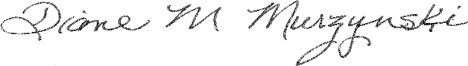
Diane M. Murzynski, NIGP-CPP, CPPO, CPPB Contracts & Procurement Officer

finance.cityofalbany.net

